Bolatkhan Akylbek

Theme: Restaurant Menu

Link to my git: <https://github.com/Akyldevil>

**Task 2. Create website template using HTML5 and CSS (second week)**

Your HTML5Template should include following responsive HTML5 and CSS3 pages’ templates:

* Main page (Home page);
* Contacts.

Some Mandatory Features:

1. Responsive Layout using HTML5 semantic elements or CSS3 layout;
2. Clean Code (coding style, comments and others);
3. Easy to Customize ;
4. On the contacts page besides of text info to display address on the map

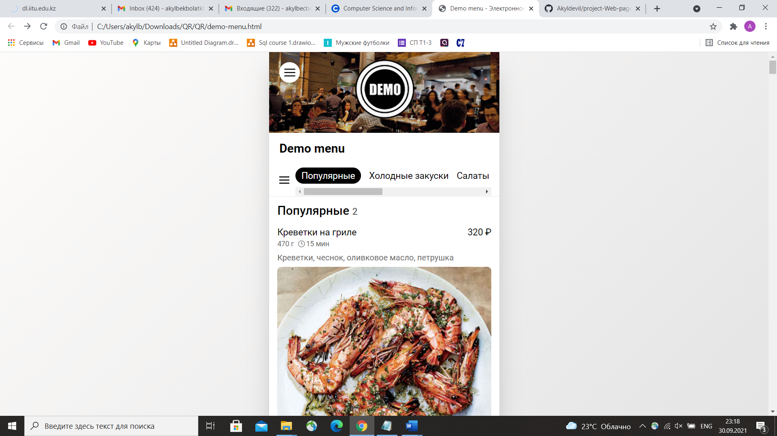

Also, we have an second version. But, in my opinion, I need to develop smartphone adapted site, due to the restaurant clients.

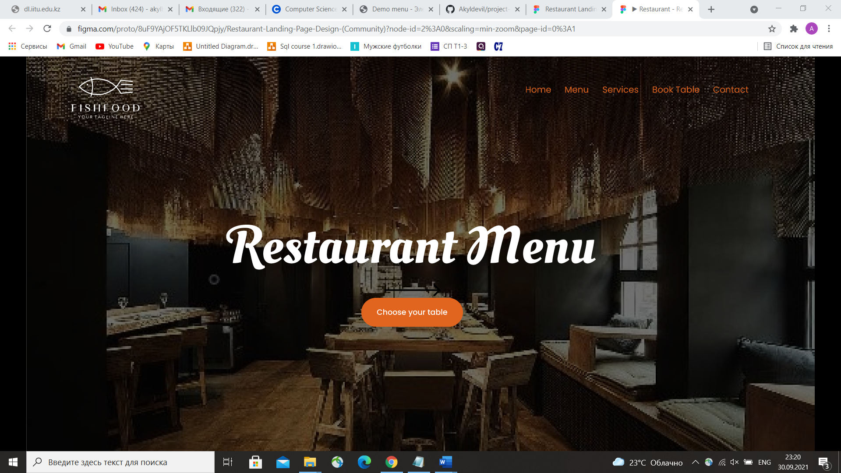

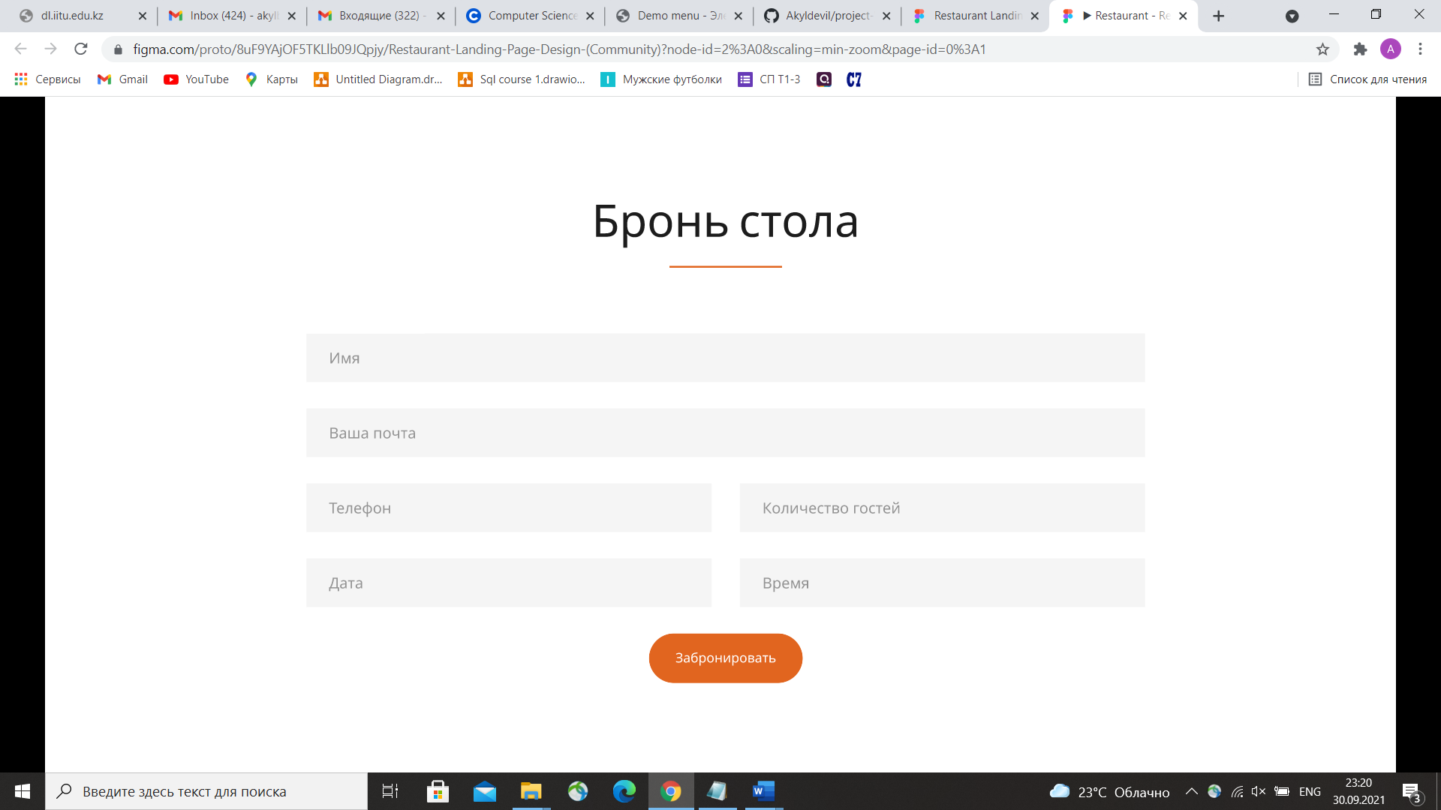

**Report**

In this laboratory 2 work we had started to create our first web page from the project based on HTML and CSS

In introduction, a page layout defines the appearance of a website, in our case, it must be appeared restaurant menu. An HTML layout is a structure that helps the user navigate through web pages easily – for example, to find dishes which he wants. It is a way in which you can design web pages using simple HTML tags.

We had used our knowledges from previous laboratory works, in addition, we had used tags(div – opening and closing). Also, practicing of attributes, elements, links and using of selectors, properties and values was learned in our laboratory work.

To conclude, starting to create our projects first pages opens new properties, with which we can use right now, for instance, show to customers our pages, and say like “Вот так могу, и так могу”, for gaining of first orderings.